**SQL TASK _1**

**1.**Create a Database product_db

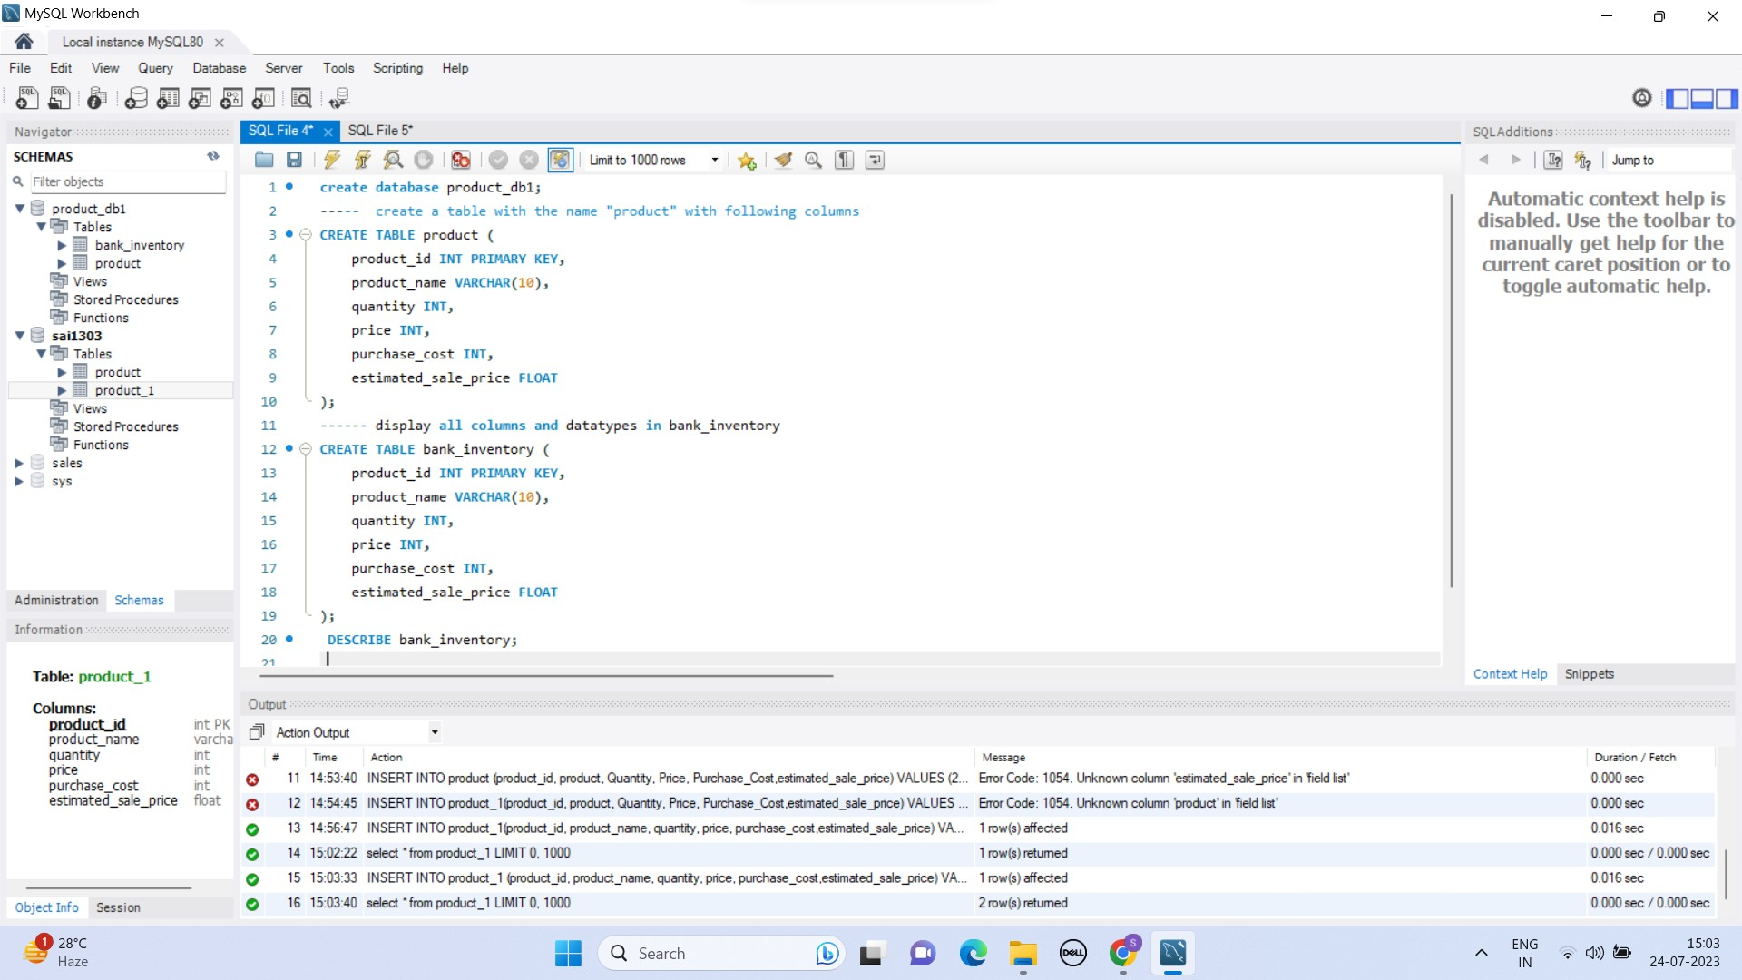

Program:

create database product_db1;

2. create a table with the name "product" with following columns:

Program:

CREATE TABLE product (

product_id INT PRIMARY KEY,

product_name VARCHAR(10),

quantity INT,

price INT,

purchase_cost INT,

estimated_sale_price FLOAT

);

3. Display all columns and data types in bank_inventory

Step 1: create table bank_inventory in a table product_1:



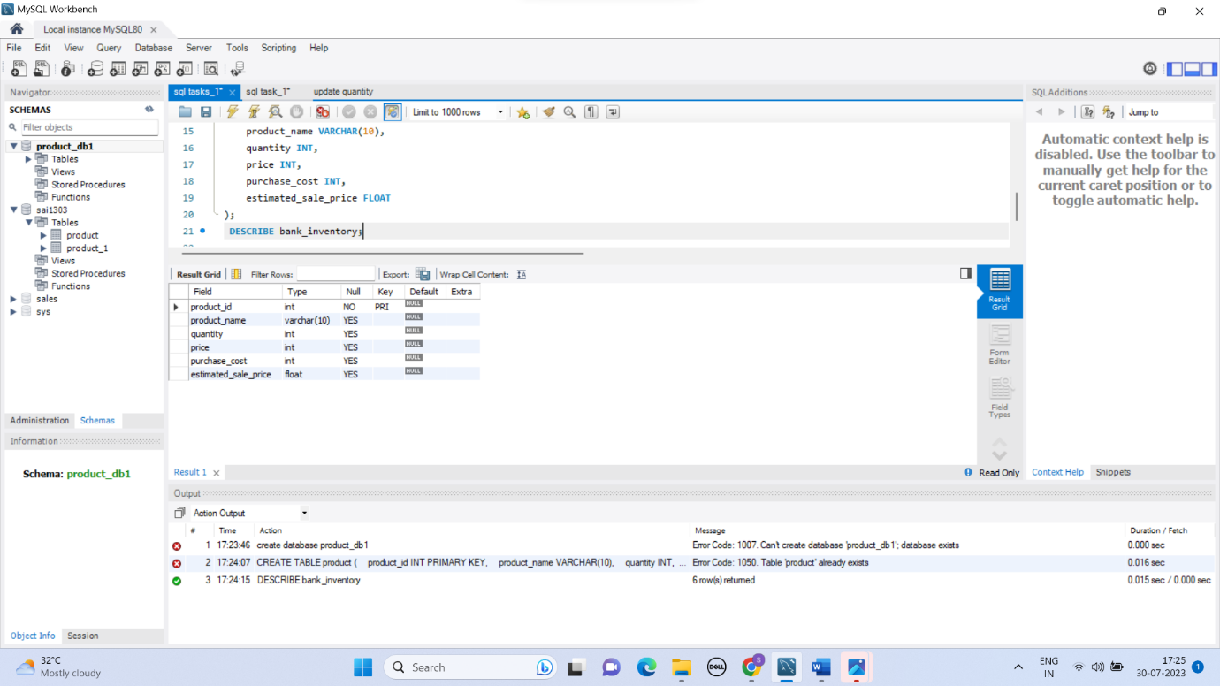

Program:

DESCRIBE bank_inventory;

4. insert the below two records into product table product-id:1,

product :Paycard,

Quantity :2

PRICE:300

PURCHASE _COST: 8000

estimated_sales_price :9000.56 IN MYSQL

insert the below two records into product table product-id:2

product : Paypoints

Quantity :2

PRICE:300

PURCHASE _COST: 7000

estimated_sales_price :6700.56 IN MYSQL

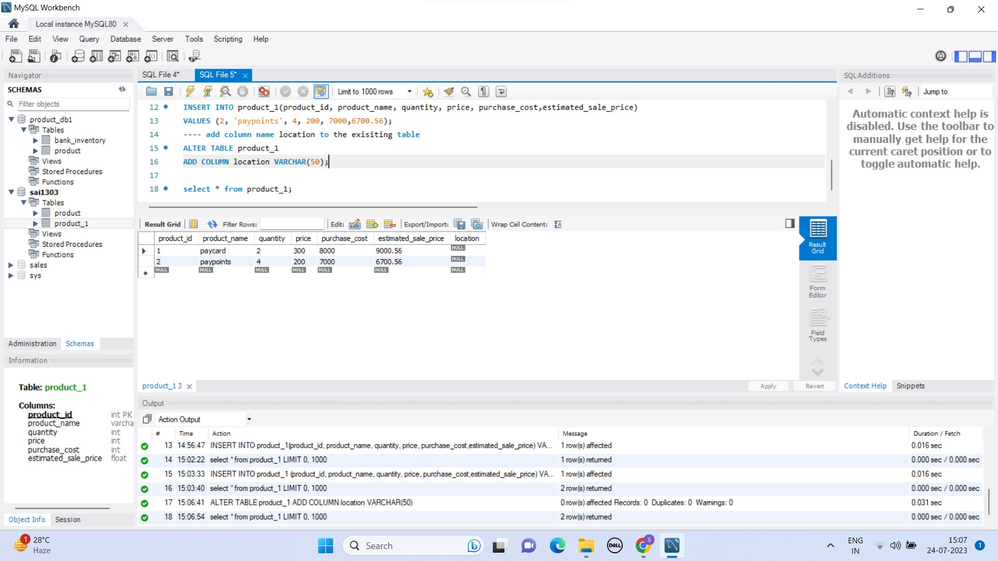

Program:

INSERT INTO product_1 (product_id, product_name, quantity, price, purchase_cost,estimated_sale_price)

VALUES (1, 'paycard', 2, 300, 8000,9000.56);

INSERT INTO product_1(product_id, product_name, quantity, price, purchase_cost,estimated_sale_price)

VALUES (2, 'paypoints', 4, 200, 7000,6700.56);

5. add column:"location" to the existing product table with data type varchar and size 50 in mysql



Program:

ALTER TABLE product_1

ADD COLUMN location VARCHAR(50);

6. Update the value of the location update location as usa for product_id=1

. Update the value of the location update location as india for product_id=1

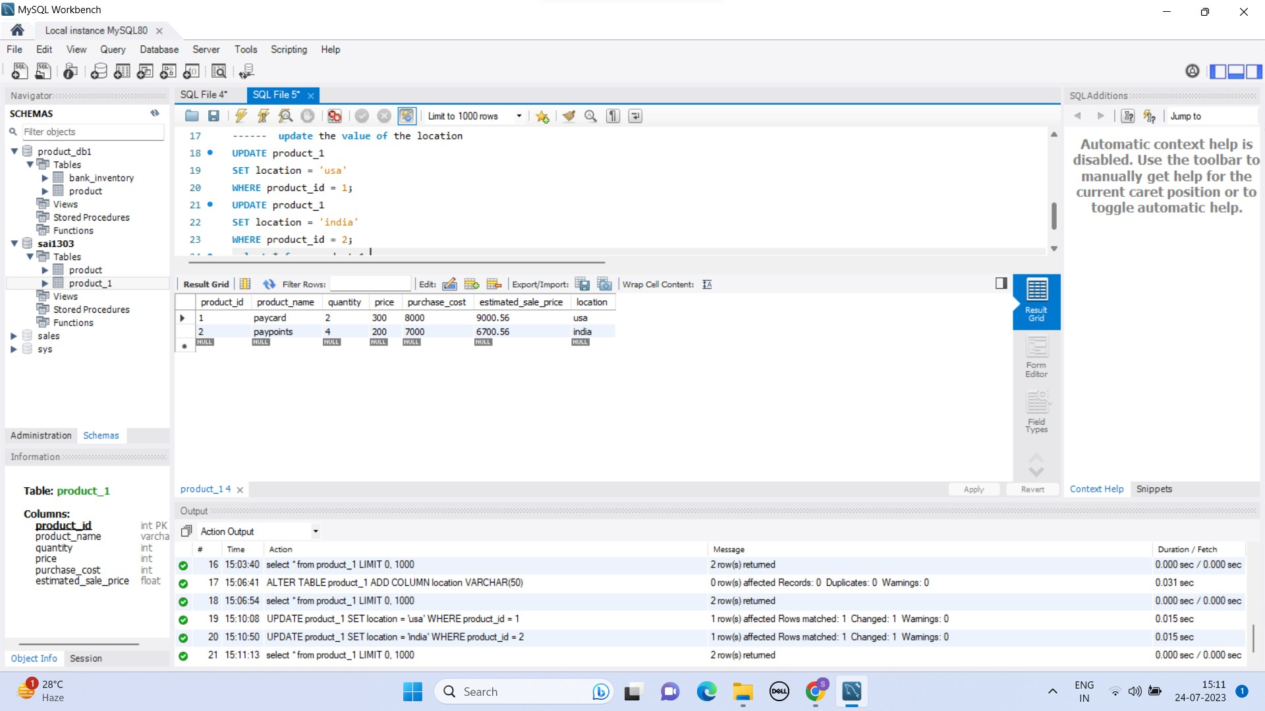

7.What is the value of location for product “pay card”

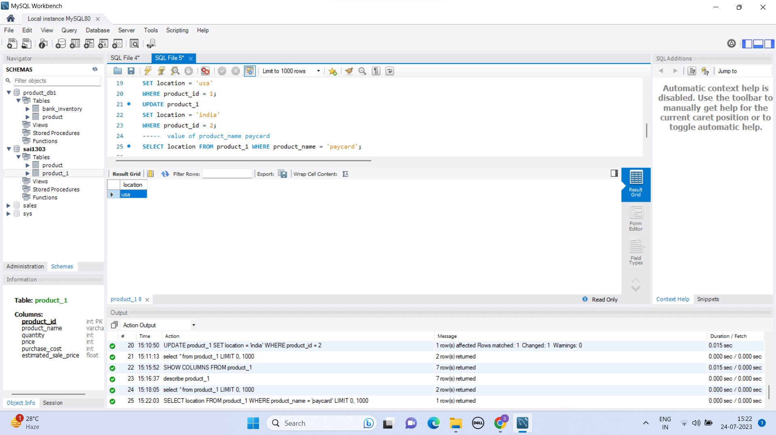

Program:

SELECT location FROM product_1 WHERE product_name = 'paycard';

8. update the product column to size of 25

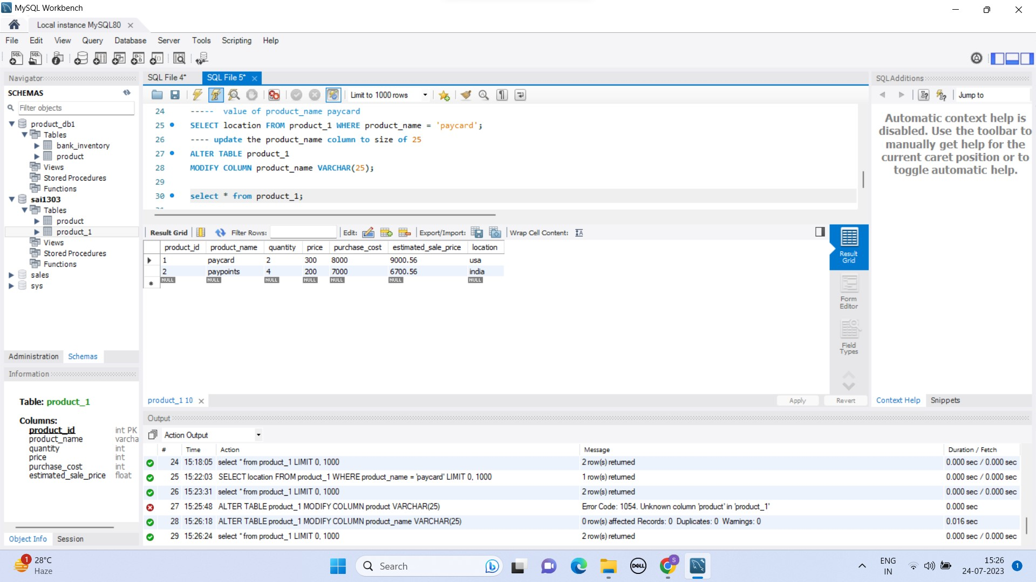

Program:

ALTER TABLE product_1

MODIFY COLUMN product_name VARCHAR(25);

9. reduce the size of location field from 50 to 20 and check if it is possible

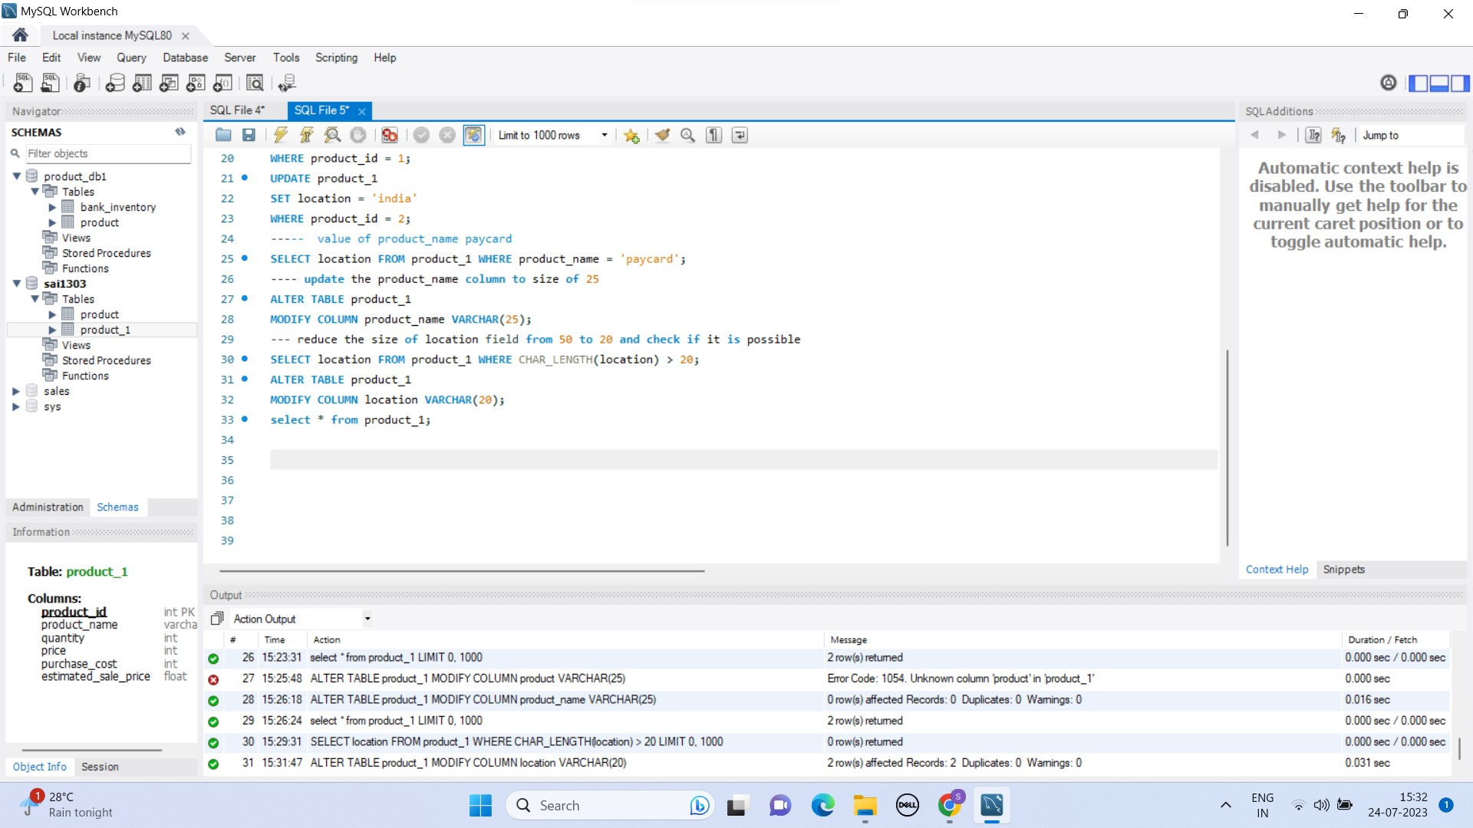

Program:

SELECT location FROM product_1 WHERE CHAR_LENGTH(location) > 20;

ALTER TABLE product_1

MODIFY COLUMN location VARCHAR(20);

10. update the quantity information of paycard product details for paycard update quantity from 2 to 10

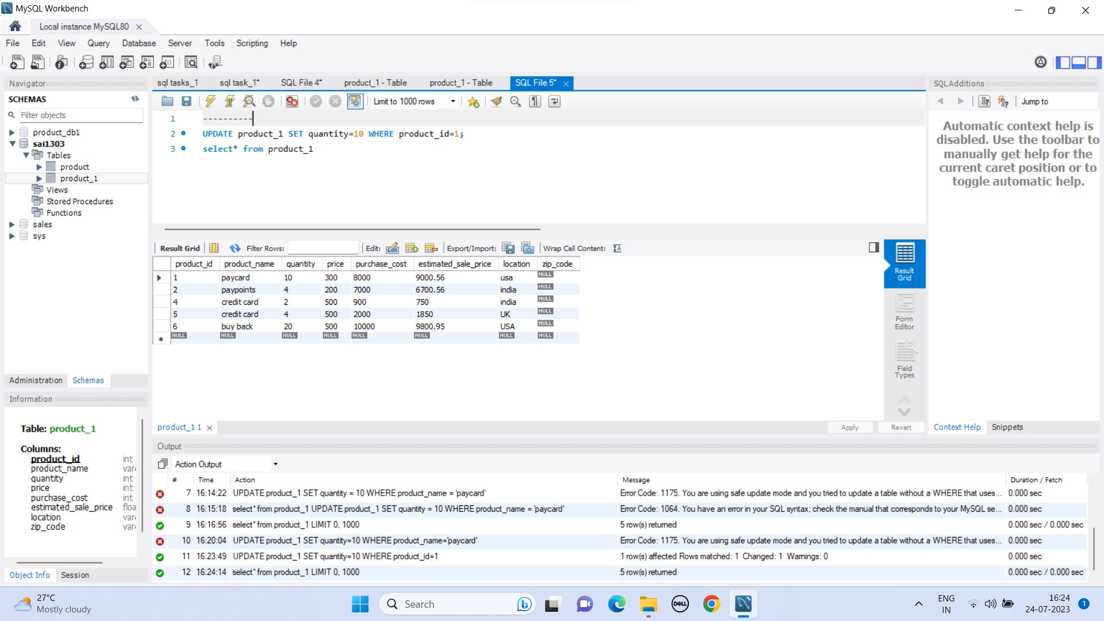

Program:

UPDATE product_1 SET quantity=10 WHERE product_id=1;

select* from product_1

11.insert one or more row /record to the table:

Product_id:4

Product: credit card

Quantity:4

Price:500

Purchase cost:900

Estimated_sales_price:750

Location: india

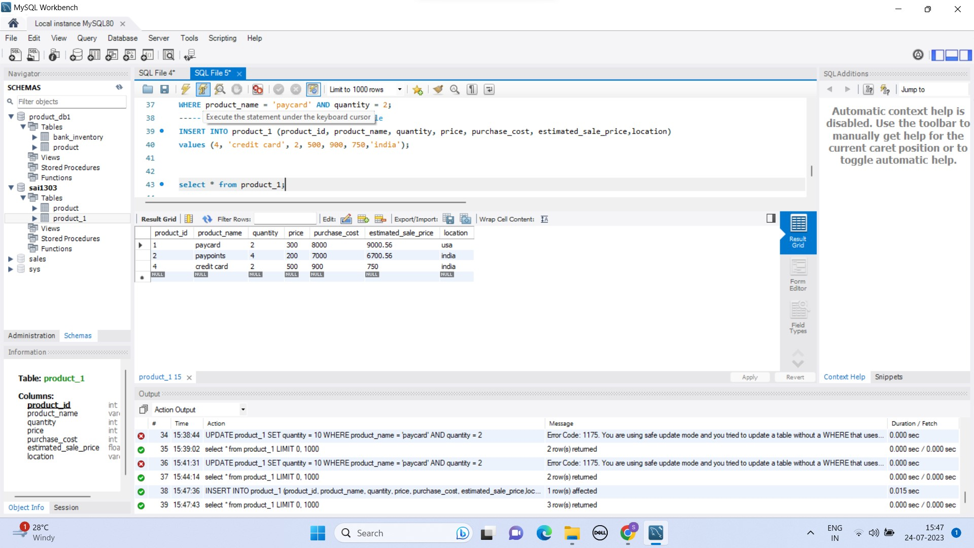

Program:

INSERT INTO product_1 (product_id, product_name, quantity, price, purchase_cost, estimated_sale_price,location)

values (4, 'credit card', 2, 500, 900, 750,'india');

12: insert two records using one query

Product_id:5

Product: debit card

Quantity:4

Price:500

Purchase cost:2000

Estimated_sales_price:1850

Location: uk

Product_id:6

Product: buyback

Quantity:20

Price:500

Purchase cost:10000

Estimated_sales_price:9800.95

Location: usa

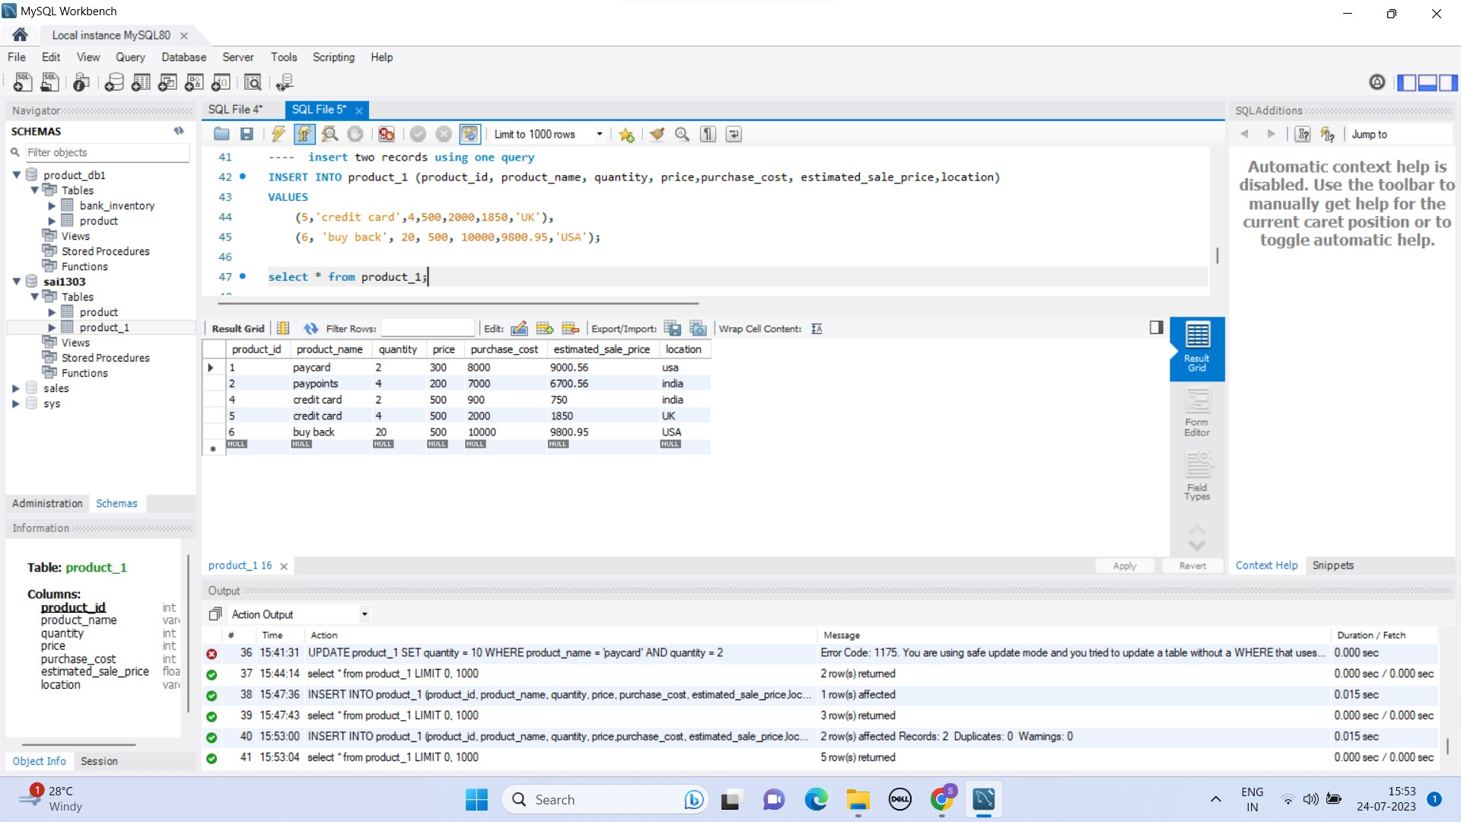

Program:

INSERT INTO product_1 (product_id, product_name, quantity, price,purchase_cost, estimated_sale_price,location)

VALUES

(5,'credit card',4,500,2000,1850,'UK'),

(6, 'buy back', 20, 500, 10000,9800.95,'USA');

13.Add column zip_code to the product table



Program:

ALTER TABLE product_1

ADD COLUMN zip_code VARCHAR(10);

14. update the zip_code to the product table by some random unique zip code to the column

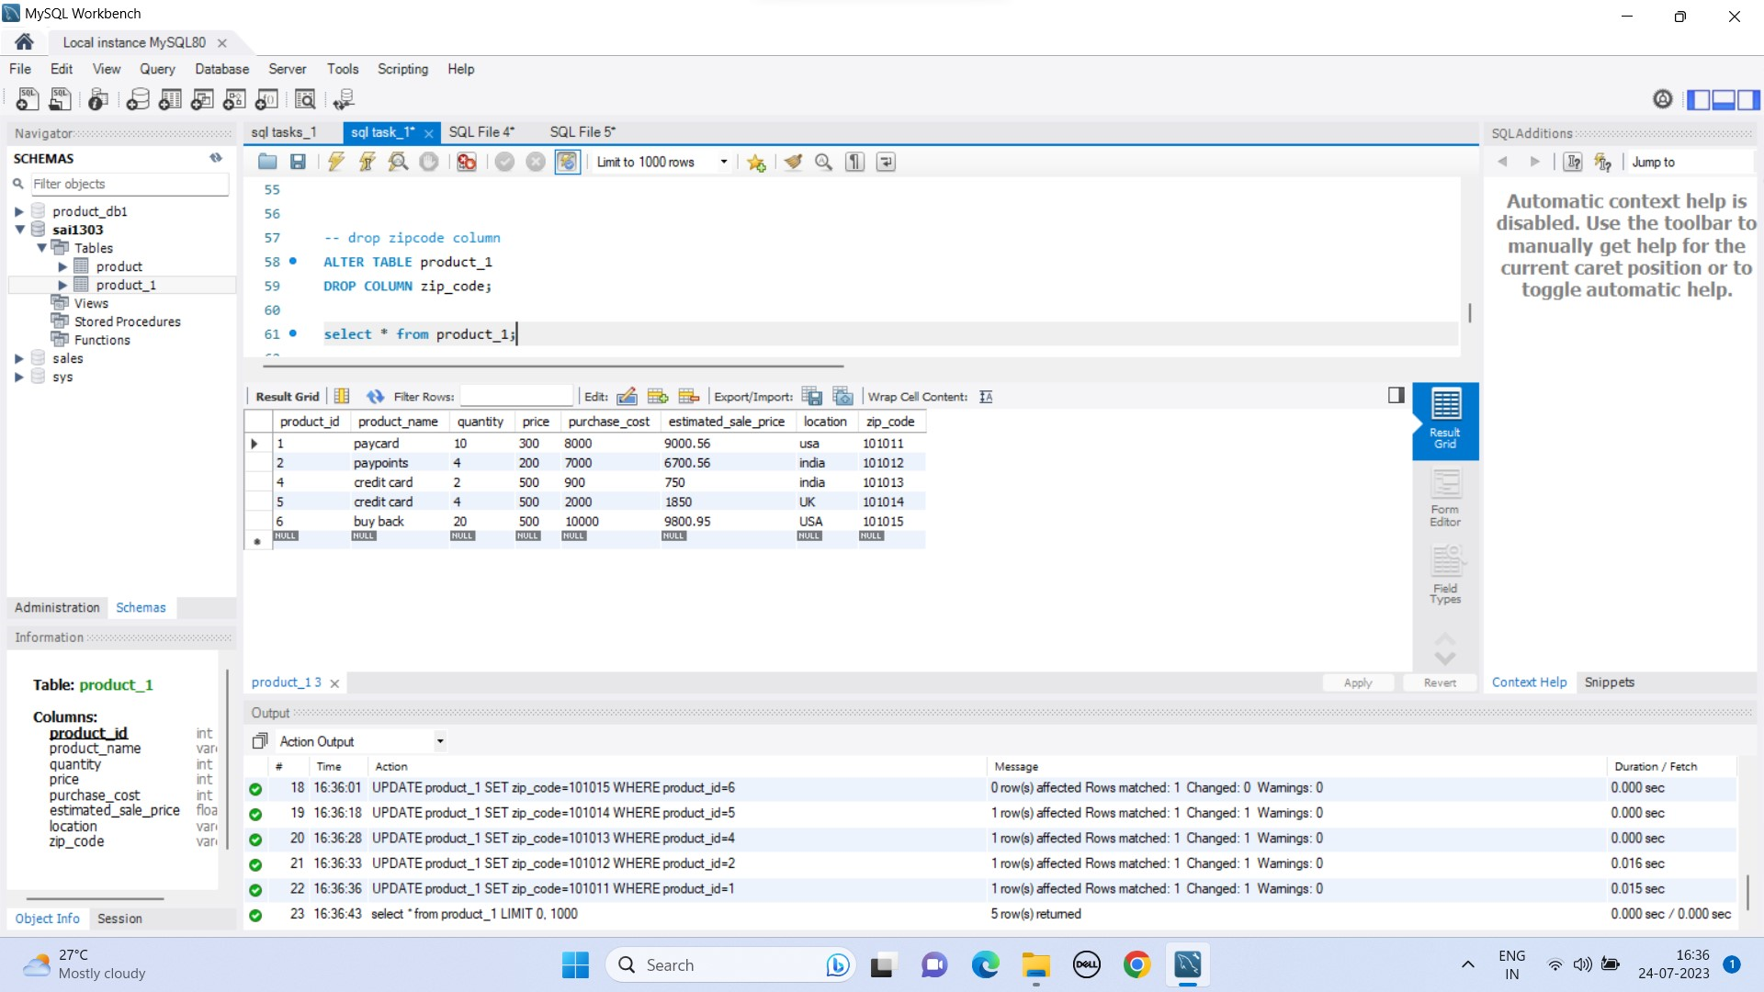

Program:

UPDATE product_1 SET zip_code=101011 WHERE product_id=1;

UPDATE product_1 SET zip_code=101012 WHERE product_id=2;

UPDATE product_1 SET zip_code=101013 WHERE product_id=4;

UPDATE product_1 SET zip_code=101014 WHERE product_id=5;

UPDATE product_1 SET zip_code=101015 WHERE product_id=6;

15.drop the column zip code from the table:

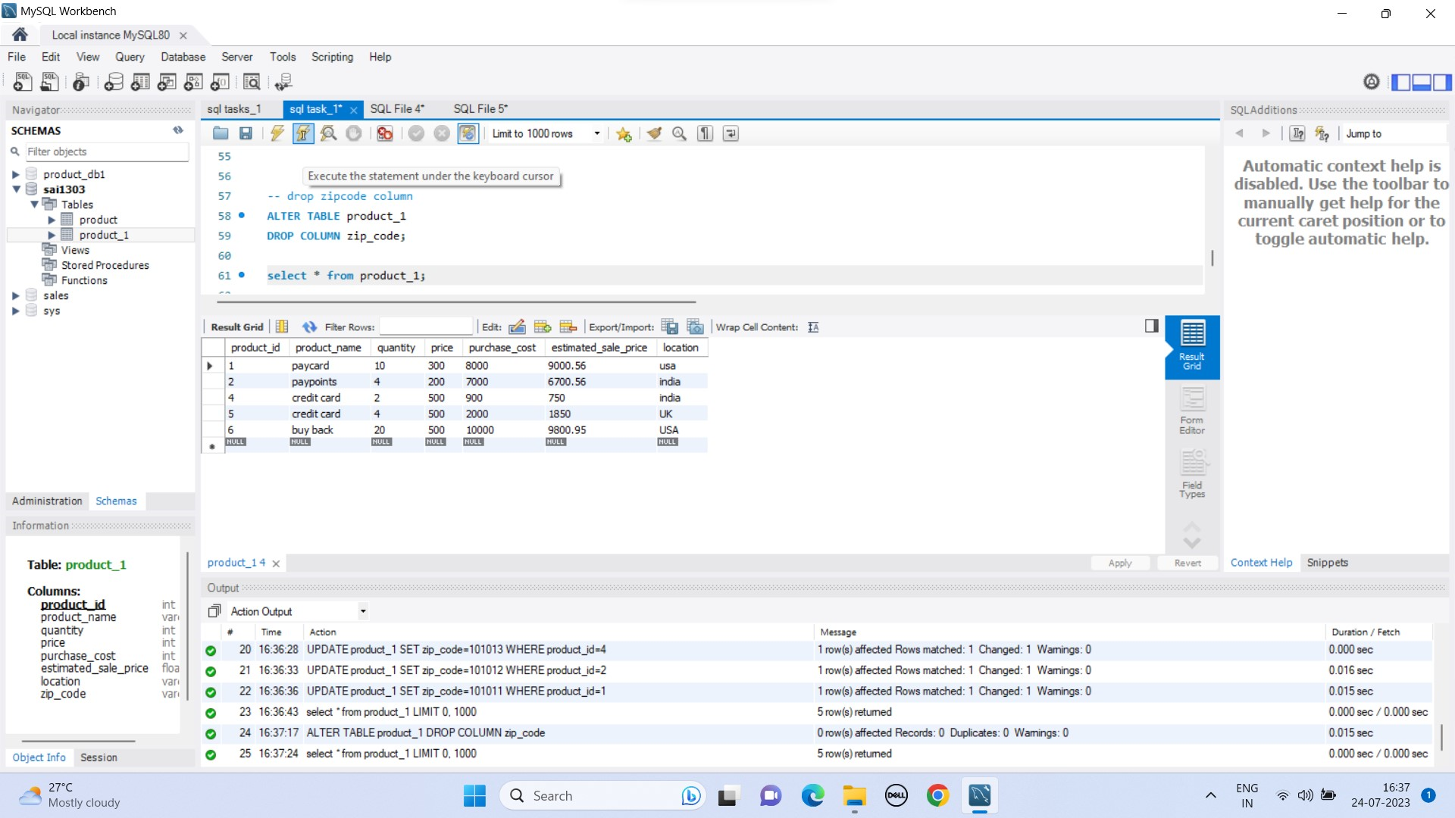

Program:

ALTER TABLE product_1

DROP COLUMN zip_code;